ECE3441_1599670_Lab3.
Anaya Scott

Overview: Goals of the Lab
Within this lab the focus was on completing a digital design from a Boolean algebra expression to a physical prototype of the expression. The overarching goal was to practice using minterm expansion using Boolean theorems that we learned in lecture. While also using Karnaugh map (K maps) to verify our theoretical outputs. Then we would transfer that information into simulations like SimUAid and then build a physical circuit to demonstrate the digital logic functionality compared to our theoretical analysis.

Step-by-Step Procedures and Results
- Write your function as a standard sum of products. Paste a picture of your
work, showing your function the expansion. Please write as clearly as you
can.
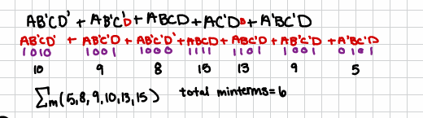
- How many minterms does your function have?
  - 6 minterms
- Paste of a picture of your work showing the theorems used for each step of the simplification process. Please write as clearly as you can.
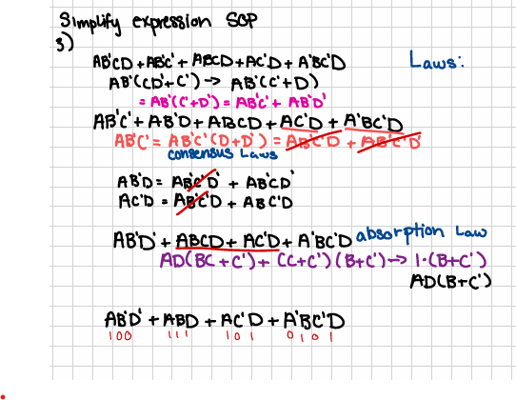
- Provide your fully simplified expression from Logic Aid or K-maps. Is it the same?
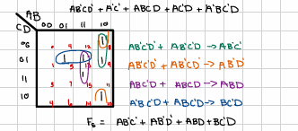
- Provide a truth table.
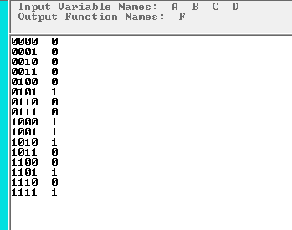
- If the number of input combinations is determined by the function 2𝑛, where n is the number of inputs for a given Boolean expression, then how many combinations of inputs are needed in total for your function’s logic circuit?
  - If there are 4inputs there are 16 combinations of inputs. 2^4 =16.
- Provide a truth table of your function using Logic Aid (or by inspecting the K- map).
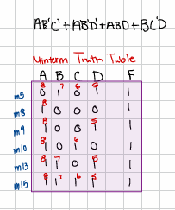
- Provide the circuit schematic of your function in your simulator.
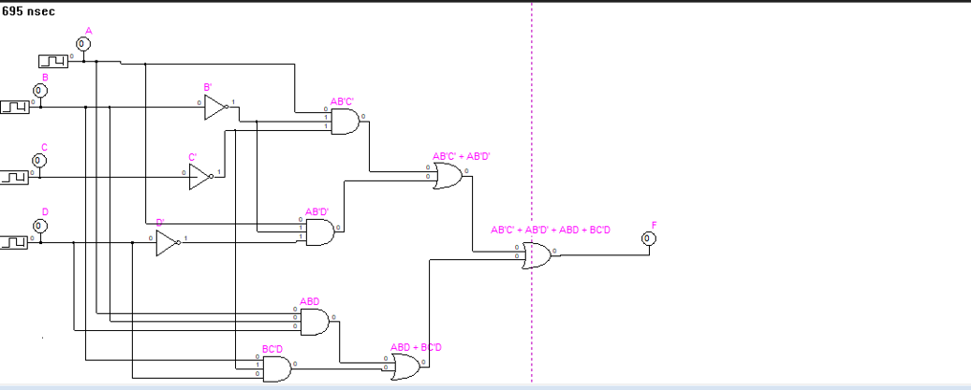
- Provide the timing diagram of the simulation.
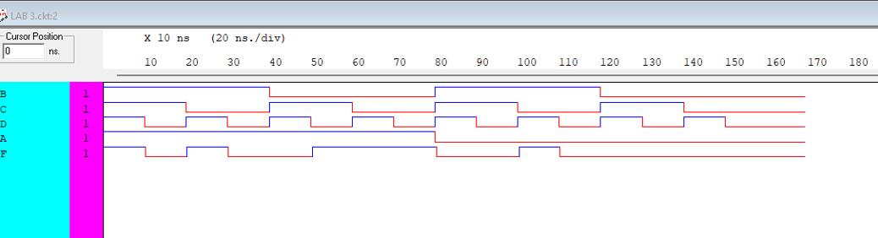
- Compare the output obtained from the simulation to the theoretical values in the truth table. Does your output match that of the truth table?
  - Yes, they do match up, as the simulations table confirms the theoretical table of all 16 input combinations.
- What pull-up/pull-down resistor values are you using and why? Please see Lab 1,
Part 2
  - I used 10K ohms as pull-down resistors because it created a continuous current for the circuit and a good balance as circuits tend to have high impedance. These resistors allowed a voltage drop at the inputs to create a more balance circuit.

Links
https://youtu.be/K6V00ir3ly0

Conclusion
What I learned in this lab was the ways in which our chips operate on a physical circuit board. While understanding the process of utilizing a Karnaugh map and truth table to understand the relationship of the given expressions. I will say that this lab truly taught me how to set up a proper functioning circuit.

